Assignment 1.4 - Business Rules

**Business Rule:** A user has one birthday.

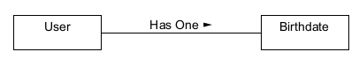

**Business Rule:** A user can have many dependents.



**Business Rule:** A User can have many roles.

